Testing Analysis – POS System
Author:Eridjon Krrashi

Method 1: saveEmployee(EmployeeDTO employee, Response response)
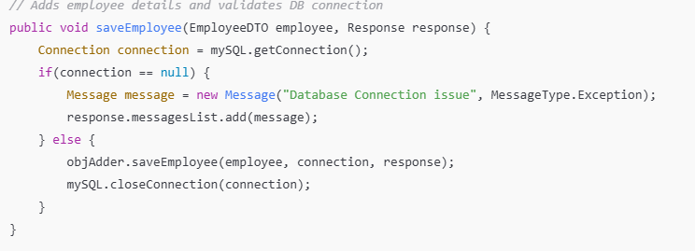
Test Cases:TC-EMP-001: ID=1, Name="A", Phone="1" → Expect: Success
TC-EMP-002: ID=100, Name=255chars, Phone=15digits → Expect: Success
TC-EMP-003: ID=0 → Expect: Response contains "Employee ID must be positive"
TC-EMP-004: Name="" → Expect: Response contains "Employee name required"
TC-EMP-005: Name=256chars → Expect: Database constraint error
Preconditions:Database connection available
Employee table empty or no duplicate ID conflict
User has appropriate permissions
Expected Responses:
TC-EMP-001/002: response.success = true, messagesList empty
TC-EMP-003: response.success = false, messagesList contains "Employee ID must be positive", messagesList[0].type = Error
TC-EMP-004: response.success = false, messagesList contains "Employee name required", messagesList[0].type = Error
TC-EMP-005: response.success = false, database returns constraint violation error
Testing Types:
Boundary Value Testing: ID ranges, Name length
Equivalence Class Testing: Valid vs invalid ID/Name/Phone
Code Coverage:
Statement coverage: both connection null and valid paths
Branch coverage: connection check, input validation
Condition coverage: ID, Name, Phone
MC/DC: each condition independently affects output
Test Priority:High: ID and Name validation
Medium: Phone format ,Low: Optional business rules

Method 2: addProduct(ProductDTO product, Response response)
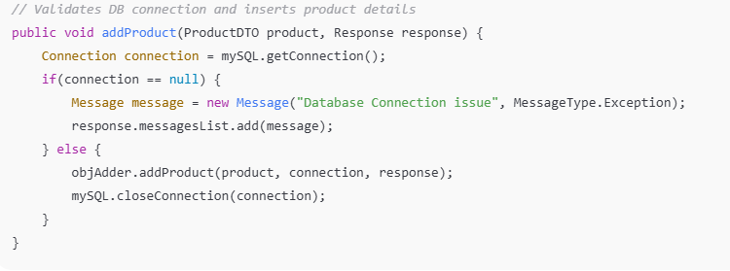
Test Cases:TC-PROD-001: Price=0, Stock=0, Name="Pen" → Expect: Success
TC-PROD-002: Price=9999.99, Stock=10000, Name=255chars → Expect: Success
TC-PROD-003: Price=-1 → Expect: Response contains "Invalid price"
TC-PROD-004: Stock=-5 → Expect: Response contains "Invalid stock"
TC-PROD-005: Name="" → Expect: Response contains "Product name required"
Preconditions:Database connection available
Product table empty or no duplicate ID conflict
User has appropriate permissions
Expected Responses:
TC-PROD-001/002: response.success = true, messagesList empty
TC-PROD-003: response.success = false, messagesList contains "Invalid price", messagesList[0].type = Error
TC-PROD-004: response.success = false, messagesList contains "Invalid stock", messagesList[0].type = Error
TC-PROD-005: response.success = false, messagesList contains "Product name required", messagesList[0].type = Error
Testing Types:Boundary Value Testing: Price and Stock limits
Equivalence Class Testing: Valid vs invalid Price/Stock/Name
Code Coverage:
Statement coverage: connection null and valid paths
Branch coverage: connection check, input validation
Condition coverage: Price, Stock, Name
MC/DC: each condition independently affects output
Test Priority:High: Price, Stock, Name validation
Medium: Optional business rules
Low: None
SummarsaveEmployee tests numeric ID ranges, Name length, Phone.addProduct tests numeric Price/Stock ranges. Both methods cover database connection success/failure paths,Equivalence Class / Decision Table analysis ensures all input combinations tested.Boundary Value Testing ensures numeric extremes
Code Coverage: 100% statement, branch, condition, MC/DC

